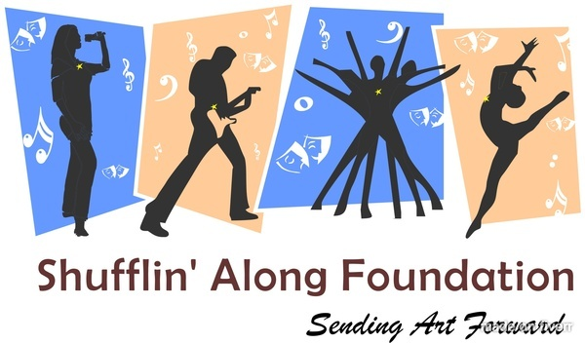
Shufflin’ Along Foundation & Performing Arts Scholarship Fund
2015 “Dance Into Your Destiny” Scholarship

Shufflin’ Along Foundation is pleased to announce the “Dance Into Your Destiny” (DIYD) scholarship which supports local dance studios in Northeast/Northwest, LA that have talented students that are also financially deserving of this award. The DIYD scholarship is strictly talent based.

“Dance Into Your Destiny” scholarship was birthed in 2014 in honor and memory of Se’Destini Fields who was an extremely gifted and talented dancer in the areas of ballet, African, jazz, tap and modern dance. Se’Destini was tragically taken from us too soon in December 2014.

The recipient of this annual award will be required to file a follow-up report on how he/she has benefited from this scholarship in their 2015-2016 dance season. The recipient will be announced at the SAF annual scholarship reception that will be held this year on April 9th at Central ArtStation @ 6:30pm. Recipient, parent(s) and or studio owner must be present.

This scholarship is $500 and will be provided to only one gifted and talented dancer at the start of their dance season at the dance studio where they are being trained. Deadline for applications is Monday, March 9, 2015 (postmarked).

We would prefer the completed application to be emailed to:
ShufflinAlongLLC@yahoo.com

If a hard copy must be sent, please send to:
Shufflin’ Along, LLC
c/o Shufflin’ Along Foundation
POB 5242
Shreveport, LA 71135

If you have any questions please contact Roshanda Spears, Founding Executive Director, Shufflin’ Along Foundation at 877-507-1913.

Shufflin’ Along Foundation & Performing Arts Scholarship Fund
2015 “Dance Into Your Destiny” Scholarship

Date of application_________________________________

Date award is needed in fall of 2015_________________________

Name of applicant___________________________________

Telephone #___________________________________

Contact name (parent/guardian)_______________________________

Email address__________________________________________

Mailing address______________________________________________

Name of dance studio applicant attends______________________________________

Telephone #_____________________________________________

Owners of the dance studio name______________________________________________

Email address______________________________________________

Mailing address____________________________________________________

How long have you studied dance at this studio___________________________________

Provide a brief description of what sparked your interest in dance
________________________________________________________________________
________________________________________________________________________
________________________________________________________________________
________________________________________________________________________
________________________________________________________________________
________________________________________________________________________
________________________________________________________________________

Provide a brief statement of why you deserve this award (financial need)
________________________________________________________________________
________________________________________________________________________
________________________________________________________________________
________________________________________________________________________
________________________________________________________________________
________________________________________________________________________

Please provide the following via video and email to: ShufflinAlongLLC@yahoo.com

- 45sec ballet combination (on pointe if applicable)
- 45sec modern combination (no shoes)
- 45sec jazz combination (jazz pants and jazz shoes)
- 45sec tap or African combination (tap shoes or no shoes)
- At the start of your video, you must state your first and last name, age, grade and what dance studio you attend
- Must be wearing black leotards and tights
- Must email a color jpeg headshot

APPLICATION CHECKLIST:

Deadline to submit your application package is March 9, 2015:
ShufflinAlongLLC@yahoo.com

Application, video, and color jpeg headshot may also be mailed to:
Shufflin’ Along, LLC
ATTN: SAF Scholarship Fund
POB 5242
Shreveport, LA 71135

Incomplete applications will not be reviewed.

___ 1. Application- all pages type-written, fully completed
___ 2. Essays- two type written
___ 3. Video (via email) of the genres listed in this application that displays your talent
___ 4. Color head shot-jpeg format (via email)

APPLICATION CERTIFICATION AND RELEASE INFORMATION:

I certify that all information on this application is true and complete to the best of my knowledge.
I certify that I meet all eligibility requirements as specified in this application and the accompanying instructions.
I understand that application materials become the property of SAF&PASF (Shufflin’ Along Foundation & Performing Arts Scholarship Fund) and will not be returned.
I hereby authorize SAF&PASF to share or publish my application, photo and video for the purpose of evaluation, recruitment, public relations, possible employment, or any other related activity.
I understand that I must notify SAF&PASF of any change in my enrollment status at my prospective dance studio. I also understand that a change in full-time status at my dance studio will result in the cancellation of any award.

Applicant’s parent or guardian:_______________________ Date:________________________

